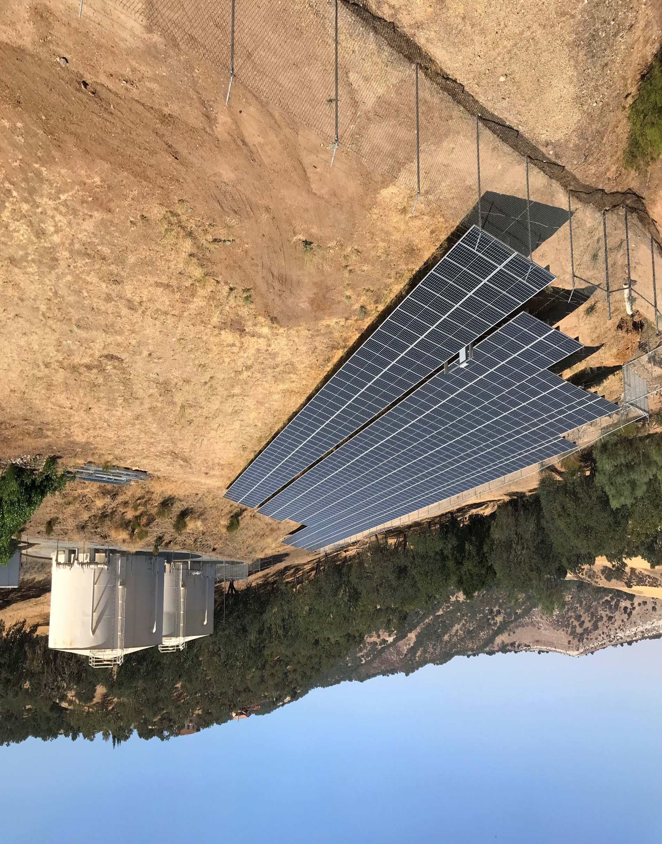
EMPLOYMENT OPPORTUNITY
Treatment Operator-in-Training

========================================================================================Open Date: July 1, 2024 Salary: Operator-in-Training: $25.77 - $31.32/hour
Closing Date: Until Filled

Salary shown is effective July 1, 2024. Current opening may be filled at a range and step depending on qualifications. Full job descriptions and information may be found on our website, www.heritageranchcsd.ca.gov.

Excellent benefits including medical and retirement (CalPERS).

First review of submitted applications may occur at any time. The position may be filled at any time thereafter.
=========================================================================
THE POSITION:
We are currently seeking a Treatment Operator-in-Training to fill full time positions. In addition, the ideal candidate provides exemplary customer service to all individuals by demonstrating a willingness to be attentive, understanding and responsive, fair, courteous and respectful, and to actively participate in maintaining a positive environment and team.
This is the trainee-level class in the treatment operator classification series. Under direct supervision, incumbents receive training in and learn to operate and maintain water and wastewater systems, facilities, and appurtenances according to District practices and procedures, as well as state and federal regulations.

TYPICAL DUTIES:
Learns to inspect, monitor, and document plant operations to ensure compliance with environmental regulations and public health standards; learns to read, record, and calculate readings of meters, gauges, and other instrumentation and interpret into operational characteristics; learns to operate and adjust treatment plant flows, pumps, motors, feeders, and other plant equipment to maintain appropriate plant operations; notifies operations staff of unusual situations; learns to collect samples and perform routine water and wastewater process laboratory tests; records and monitors results; learns to operate valves, pumps, and automated controls to regulate the flow of water and wastewater through the system.
Learns and performs basic construction, maintenance, and repair activities of District water and wastewater utilities systems and facilities to ensure safe and efficient access for the public; and performs other duties as assigned.

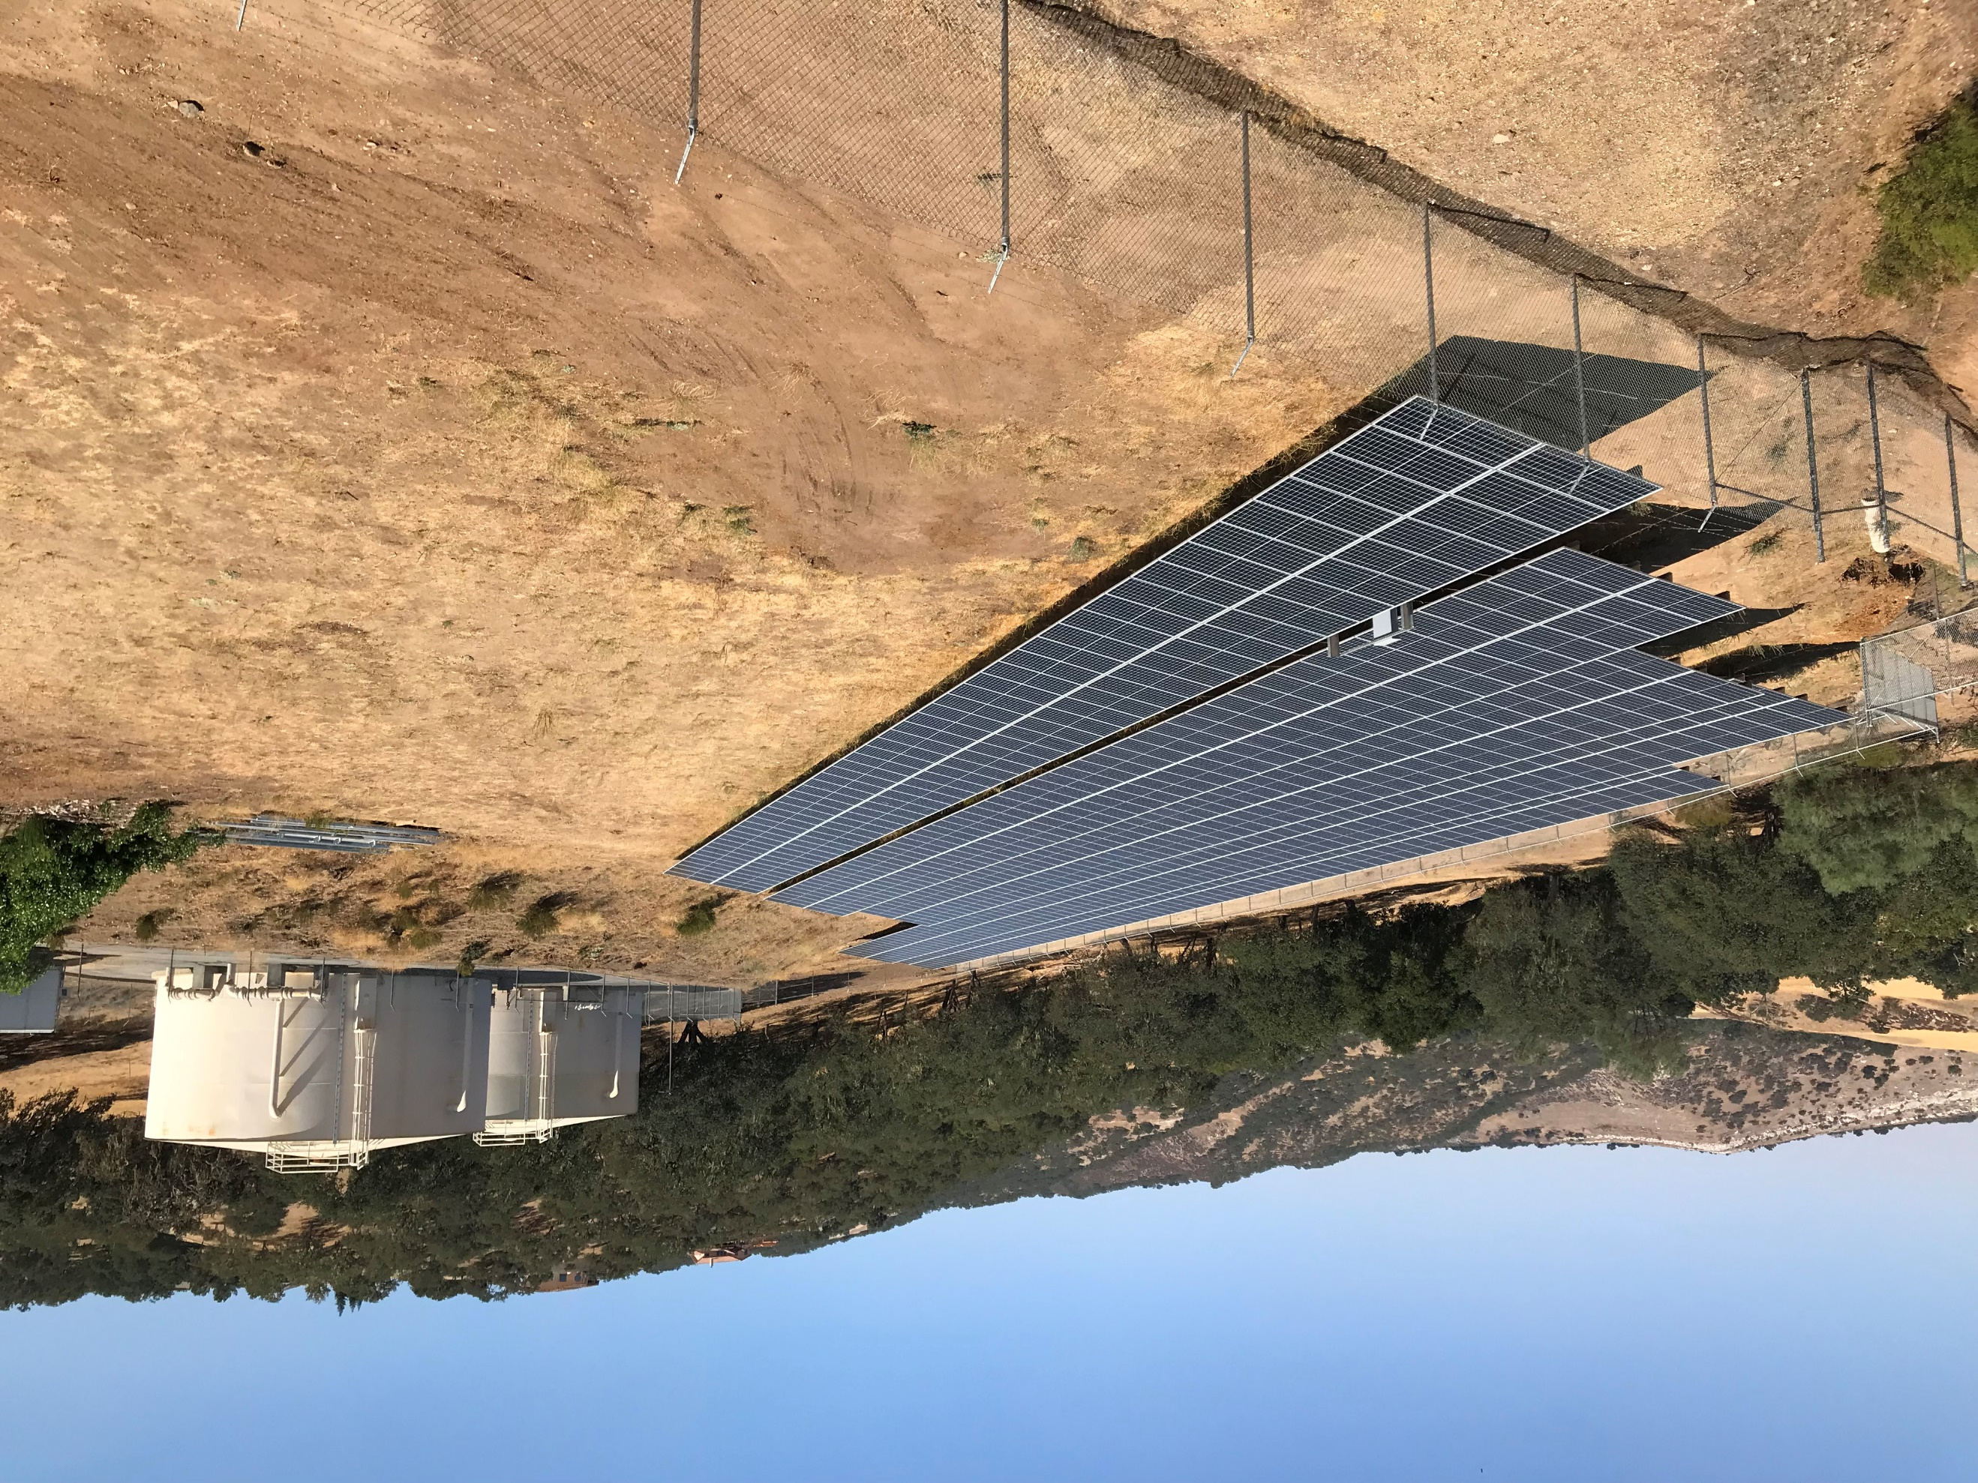
EMPLOYMENT STANDARDS:
Qualifications:
Knowledge of: Basic construction, maintenance, and repair principles, practices, tools, and materials; the operation and minor maintenance of a variety of hand and power tools, vehicles, and power equipment; basic mathematics; safe work methods and safety practices pertaining to the work including the handling and storage of hazardous chemicals; safe driving rules and practices; basic computer software related to work; record keeping principles and procedures; English usage, grammar, spelling, vocabulary, and punctuation; techniques for providing a high level of customer service by effectively dealing with the public, vendors, contractors, and District staff.

Education & Experience:
Any combination of training and experience that would provide the required knowledge, skills, and abilities is qualifying. A typical way to obtain the required qualifications would be:
Equivalent to the completion of the twelfth (12th) grade and one (1) year of experience in construction, maintenance, and repair.

Special Requirements: California Driver’s License. Must have and maintain a satisfactory driving record and be insurable to operate District vehicles.

SELECTION PROCEDURE:
Applications received by the filing date will be reviewed for accuracy, completeness, & job related qualifications. A limited number of persons whose applications clearly demonstrate they most closely meet the requirements will be invited to participate in the selection process. Appointment is subject to successfully passing an oral interview, written test, and background check. A pre-employment physical including drug screening is required. Before starting work, applicants must present documentation of their identity, authorization to work in the U.S., and a valid California Driver’s License. The provisions of this bulletin do not constitute a contract expressed or implied and may be revoked without notice.

APPLICATION PROCESS:
A job description and application may be obtained at the Heritage Ranch Community Services District Office, 4870 Heritage Road, Paso Robles, CA 93446 (Mon.-Fri. 7:30-4:00), or email by calling (805) 227-6230, or are available on our website at www.heritageranchcsd.ca.gov.

Applications must be completed and received in the District Office. Faxes are not accepted. Resumes will not be accepted in lieu of a completed application but may be attached. All statements made on the application are subject to verification; false statements will be cause for disqualification or discharge.

